|  |
| --- |
| **Titan Company Limited** |
| Financial Report |
|  |
|  |
| **Devendra Kumar Maurya** |
| **8/24/2020** |

|  |
| --- |
| This report is the financial analysis of the company Titan Company Limited for the year 2020. This report contains company overview , detailed financial analysis and recommendations for future |

**Contents**

|  |  |  |
| --- | --- | --- |
| S. No | Content | Page .No |
| 1 | Corporate Overview | 3 |
| 2 | Present Scenario | 4-5 |
| 3 | Company Brands / Diversification | 6 |
| 4 | Financial Highlights | 7 |
| 5 | Industry Overview | 8-9 |
| 6 | Business Model | 10-11 |
| 7 | Board of Directors | 12-13 |
| 8 | Share-Holders Information | 14-15 |
| 9 | SWOT Analysis | 16-17 |
| 10 | Financial Statements | 18-21 |
| 11 | Ratio Calculation and Interpretation | 22-36 |
| 12 | Recommendation | 37 |

**Corporate Overview**

**The Titan Journey**

Titan was established in 1984 as a joint venture between the Tata Group and Tamil Nadu Industrial Development Corporation (TIDCO). Its primary aim was to create world-class watches for every Indian. In three decades, the Company has built an impressive watch business to become India’s largest manufacturer and one of the largest integrated watch manufacturers in the world. Titan’s strategy of establishing excellence in every part of the value chain makes it a leader in every industry that it operates in.

Titan entered the jewellery business in 1995. Jewellery is sold in India through an exclusive company-controlled retail chain, comprising owned and franchised outlets. Titan forayed into optical retail in 2007 with a range of frames, prescription eyewear, contact lenses and sunglasses. The Company has set up its corporate office in Bengaluru (Karnataka) and has manufacturing facilities in Tamil Nadu, Karnataka, Uttarakhand and Sikkim. Globally, Titan has a presence in over thirty countries through its marketing.

**Company Vision**

We create elevating experiences for the people we touch and significantly

impact the world we work in.

**Company Mission**

We will do this through a pioneering spirit and a caring, value-driven culture

that fosters innovation, drives performance and ensures the highest global

standards in everything we do.

**Values and Standards**

**Total Customer Orientation**

Customers take precedence over everything else, always.

**Employee Appreciation**

We value and respect Titanians and endeavour to fulfil their needs and aspirations.

**Performance Culture and Teamwork**

At Titan, high performance is a way of life and is nurtured by teamwork.

**Creativity and Innovation**

We continue to grow and set new standards for innovation and quality with each new offering.

**Passion for Excellence**

In all our pursuits, we ceaselessly strive for excellence.

**Corporate Citizenship**

Titan believes in being a responsible corporate citizen and pro-actively engages in issues concerning community it operates in and the environment in general.

**Present Scenario**

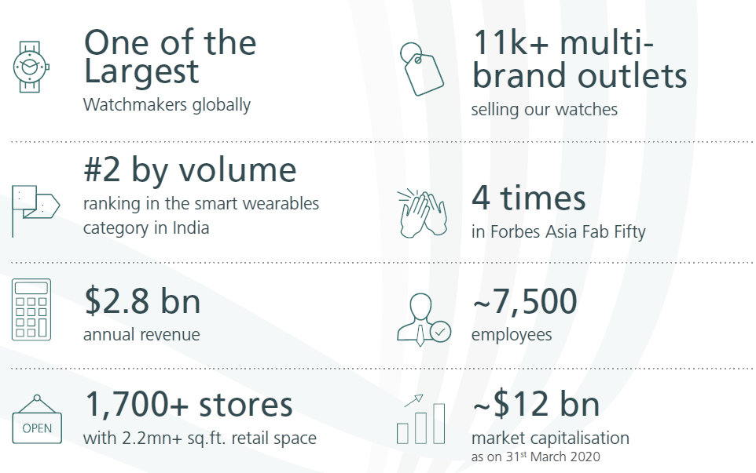

**Strengths and Differentiators**

**Design and Development**

• 800+ New time products every year

• Red Dot Award to 2 Edge watches

• Differentiated jewellery collections

• Customised lenses with 3D visual mapping

**Manufacturing**

• 15 Manufacturing and assembly facilities

• State-of-the-art Karigar Centres for jewellery

• Components exported to Swiss watch makers

• 3600+ employees engaged in factories

**Brand Building**

• Tanishq: India’s leading jewellery brand

• Titan: Our flagship watch brand

• Raga: Exclusive women’s watch brand

• Fastrack: India’s largest youth brand

• Sonata: India’s largest selling watch brand

• SKINN: Leading perfume brand in India

• Taneira: Special occasion wear saree brand

• Titan EyePlus: India’s largest optical retail chain

**Retail and Customer Service**

• Exceptional customer experience

• Merchandising effectiveness

• Impactful retail identities

• Engagement of store staff

• Extensive after sales service network

**Company Brands / Diversification**

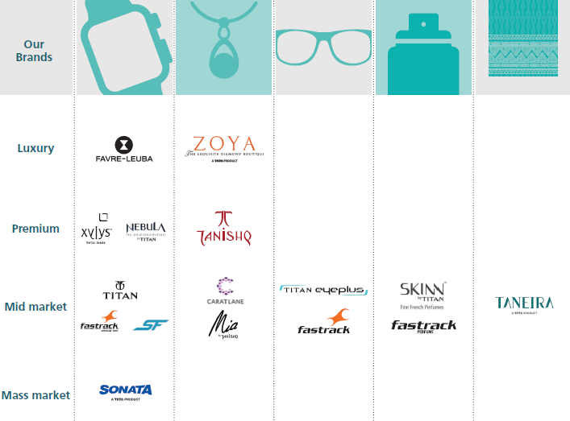

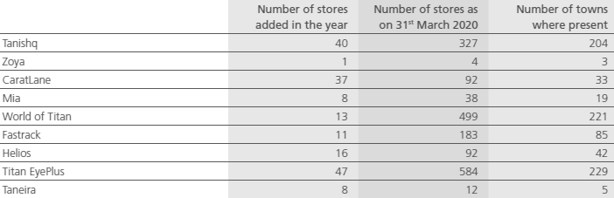

###### **Financial Highlights**

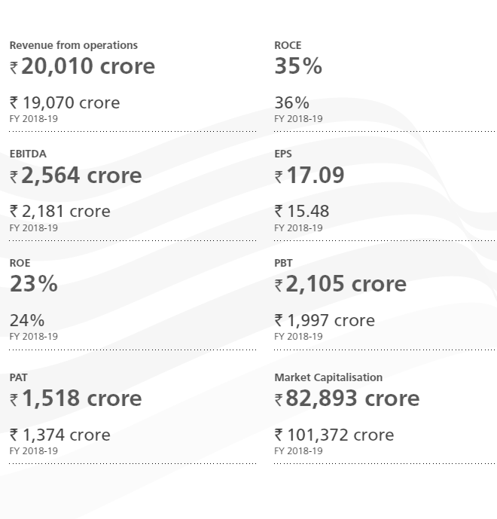

**Industry Overview**

Titan is a type of Lifestyle Industry. Titan is one of the largest watch producer in India and sixth largest in the world. Titan manufactures over 7 million watches per annum and have 65 million customer.

The global watches market size was valued at USD 50.1 billion in 2018. Increasing fashion trends among people and rising disposable income of the working class population on a global level are projected to remain favorable factors in the market. Furthermore, increasing number of new product launches in the smart and fitness watches segments by telecom companies including Apple Inc. and Xiaomi is projected to expand the watches market reach over the next few years.

The India watch market is projected to grow at a CAGR of 20.32% over the forecast period, 2020-2025. By product type, the quartz segment holds the maximum share, however, the smart watch segment was the fastest growing segment, mostly followed by an increasing demand coming from fitness sports and health-conscious consumers. On the other hand, the lower priced and mid-priced watches are increasingly gaining market traction, due to an increasing demand for value-for-product watches and accessories among women.  
  
By distribution channel, the offline retail channel holds a major share and under the offline retail channel segment, specialty stores accounted for the prominent share and it turned out to be the largest segment as well. Furthermore, Mono-brand specialty stores are gaining popularity across the country, which for instance, a significant number of the chain stores of Titan are operated through 'World of Titan' outlet franchises.

**Key Market Trends**

Consumer inclination towards luxury goods  
  
Luxury is no longer restricted to developed countries but is also gaining popularity in developing countries of Asia-Pacific. In India, watches are considered as a part of fashion accessories and, thus, consumers are shifting from classical watches to luxury brands with innovation and unique design. Furthermore, India is a lucrative market for various luxury brands, owing to the presence of royal heritage and availability of technological assets.  
  
Some of the major brands offering luxury watches in India include Rolex, Omega, Rado, and Tissot, and due to the increasing demand, other companies have identified the potential and invested in expanding their product portfolio to strengthen the position in the market.  
  
Increased sports participation  
  
Healthy lifestyle adoption and the preference for staying fit has increased consumer indulgence in various sports activities. In line with the athleisure trend, consumers are increasingly seeking for various varieties in sports wearable segment, thereby, accelerating the smartwatch sales.  
  
Presently, the usage of smartwatches among cyclers, runners, fitness conscious consumers, swimmers, and athletes is increasing rapidly attributed to their wide range of monitoring capabilities. Additionally, an increase in government initiatives in various countries, meant to improve sports participation, is playing a key role in driving the market in the last few years. For instance, In September 2019, Sports Authority of India (SAI) with technical and organizational support from AIFF (All India Football Federation) launched Khelo India Girls League. The initiative was part of the government's effort to create a buzz for the U-17 women's football World Cup.

**Competitive Landscape**

The market studied is expected to witness a significant growth over the forecast period, owing to the adoption of various marketing strategies, such as product innovation, expansion of distribution network, and branding of the products via social media, with an aim to broaden their customer base.  
  
Titan, Timex, Casio, Swatch Group, Rolex, Fossil, and Citizen are some of the major companies operating in the market studied. Titan is the most dynamic participant in the market that has segmented the market and developed different sub brands for each segment. On the other hand, foreign brands, like Omega, which belongs to the Swatch Group, India, witnessed a higher growth than the company's global average in 2018.

**Buisness Model**

Business model leverages on unique value drivers to provide high quality products and

services and create value for all of the stakeholders in a responsible and sustainable way.

**Intellectual Capital**

The Company provides the required impetus to intellectual capital through investments in technologies, interventions and collaborative approaches for bringing in cutting-edge technologies as well as giving a fillip to design and innovation to drive growth for the Company. Consequentially, financial capital, manufactured capital, natural capital, human capital and social and relationship capital are likely to be positively impacted.

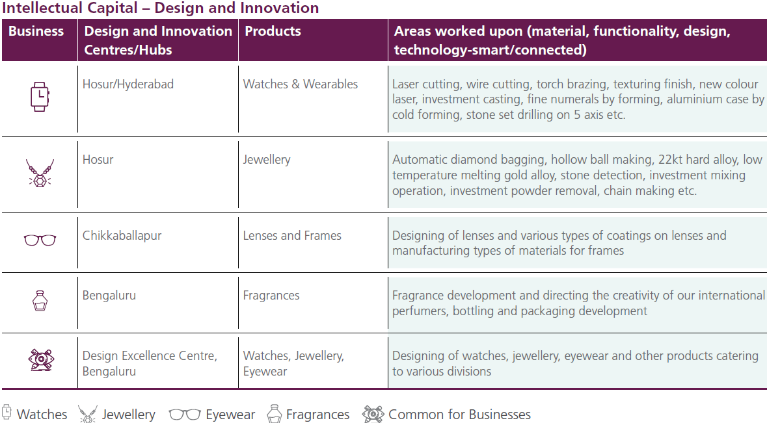

**Human Capital**

Built on the foundation of the Company’s values and a commitment to the Tata Code of Conduct, the Company strives to provide a safe, challenging and rewarding environment for each of its employees. The motivated and committed employees are the catalysts who drive the business and create value for all the stakeholders. The Company is committed to empower its people

and build an organisation on strong business and cultural values. The skills, experience, diversity and competencies of the employees enable the Company to operate safely, reliably and sustainably, and deliver on its growth objectives.

###### **Financial Capital**

The Company aims to create value for all its stakeholders by managing the financial capital in a commercially astute and diligent manner thereby harnessing opportunities for long-term sustainable economic growth.

While the provision of high quality and affordable products and services directly benefit the Company’s consumers, a focus on building a profitable and sustainable business model generates

economic value for varied stakeholder groups.

**Social and Relationship Capital**

As a lifestyle products company, the success of the Company’s endeavour is largely attributed to maintaining excellent relationships with key stakeholders in the value chain. Anchored by the Tata ethics and values, the Company has created long-lasting pleasant experiences for everyone,

including karigars, vendors, business associates and customers. It is these networks of association and social capital that are cornerstone to the brand value of the Company. Core to the business is the customer connect, that happens through countrywide retail network. A focussed channel strategy as well as modernising retail stores and sales channels has driven customers to stores leading to volume and value growth.

**Manufactured Capital**

The Company’s state-of-the-art manufacturing facilities as well as the collaborative approach with suppliers and associates is crucial in creating sustainable value. The Company continuously invests in upgrading technology and processes to improve the efficiency and effectiveness of its

manufacturing capabilities. With an aim to leverage opportunities and provide employment, apart from setting up manufacturing plants, assembly units, lens labs and karigar centres, the

Company has also built relationships with a large number of suppliers and associates. This effective synchronisation enables the Company to deliver high in the eyewear business, the satellite lens labs located at strategic locations, work closely with the stores to reduce turnaround times and enable them to deliver spectacles on the same day. The initiative has been extremely successful and has become a differentiator at many of the stores. This has also led to increase in sales of its frames and lenses quality products to customers across markets.

**Natural Capital**

As a responsible manufacturer, the Company recognises the importance of the use of natural resources to create high value products. The Company is dedicated to minimising the negative

environmental impact of its operations including from the manufacturing units, karigar centres and office spaces. The Company has established internal controls to mitigate the compliance

risks associated with increasingly stringent requirements regarding air quality and effluent management. Key focussed efforts include investments in renewable energy, recycling of water

and waste reduction. The Company is implementing several initiatives to reduce specific energy

and water consumption across its manufacturing locations. The Company has also set targets for improvement on environmental aspects, including achieving carbon neutrality.

###### **Board of Directors**

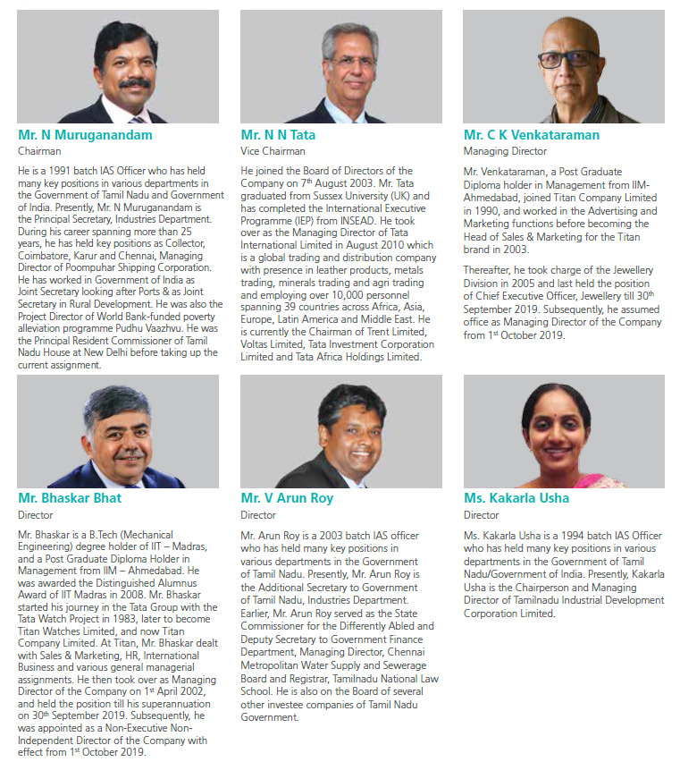

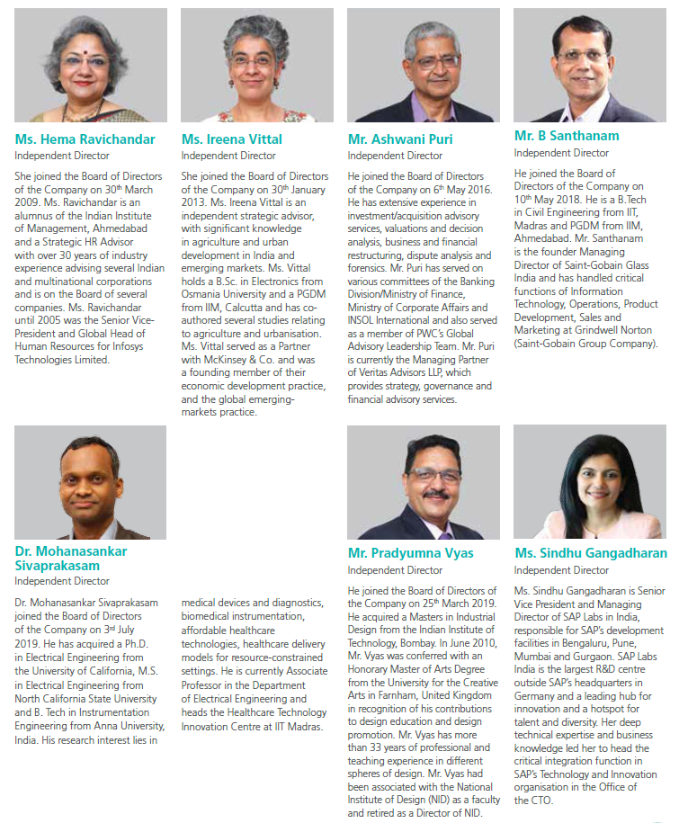

###### **Share-Holders Information**

###### **Share- Holdings of Promoters**

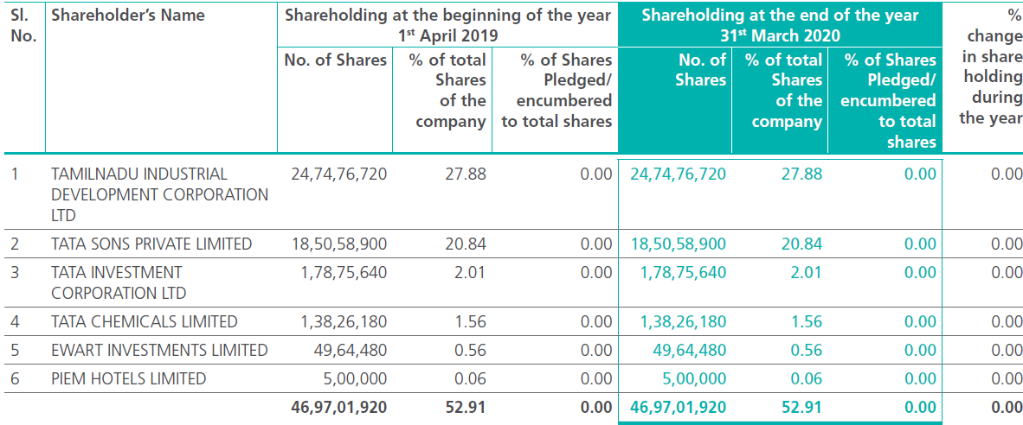

**Shareholding of Top 10 Shareholders**

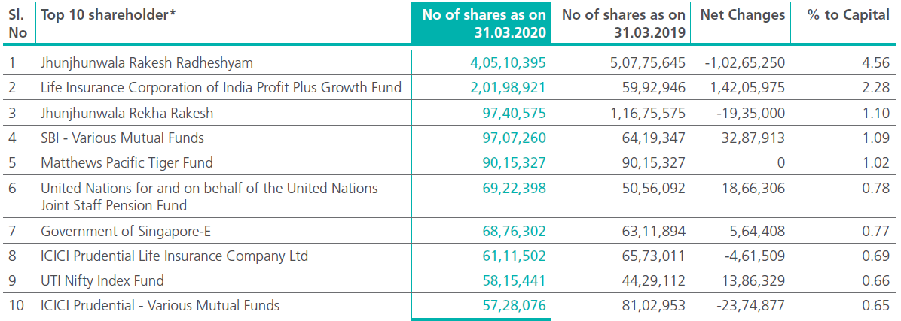

###### **Comments –**

Titan is jointly owned by Tata Group and Tamil Nadu Industrial Development Corporation (TIDCO). Tata Group is owned by [Tata Sons](https://en.wikipedia.org/wiki/Tata_Sons).It is one of the biggest and oldest industrial groups in the country, founded 153 years ago in 1868. Each Tata company operates independently under the guidance and supervision of its own board of directors and shareholders.

Significant Tata companies and subsidiaries include [Tata Chemicals](https://en.wikipedia.org/wiki/Tata_Chemicals), [Tata Communications](https://en.wikipedia.org/wiki/Tata_Communications), [Tata Consultancy Services](https://en.wikipedia.org/wiki/Tata_Consultancy_Services), [Tata Consumer Products](https://en.wikipedia.org/wiki/Tata_Consumer_Products), [Tata Elxsi](https://en.wikipedia.org/wiki/Elxsi), [Tata Motors](https://en.wikipedia.org/wiki/Tata_Motors), [Tata Power](https://en.wikipedia.org/wiki/Tata_Power), [Tata Steel](https://en.wikipedia.org/wiki/Tata_Steel), [Voltas](https://en.wikipedia.org/wiki/Voltas), [Tata Cliq](https://en.wikipedia.org/wiki/Tata_Cliq), [Titan](https://en.wikipedia.org/wiki/Titan_Company), [Trent (Westside)](https://en.wikipedia.org/wiki/Trent_(Westside)), [Indian Hotels Company Limited](https://en.wikipedia.org/wiki/Indian_Hotels_Company_Limited), [TajAir](https://en.wikipedia.org/wiki/TajAir" \o "TajAir), TATA AutoComp systems Ltd, [Vistara](https://en.wikipedia.org/wiki/Vistara" \o "Vistara), [Cromā](https://en.wikipedia.org/wiki/Crom%C4%81" \o "Cromā) and Indicash.

The group operates in more than 100 countries across six continents, with a mission 'To improve the quality of life of the communities we serve globally, through long-term stakeholder value creation based on Leadership with Trust’.

Tata Group of Companies has always been a very value-driven organization. And these values have guided them to gain success over the years. The five core values, which define Tata Sons Ltd, are **excellence**, integrity, pioneering, responsibility and lastly unity. Their motto is “Leadership with Trust”.

One of the top stakeholder is **Rakesh Jhunjhunwala.** he is one of the most famous and respected equity investors in India and manages his own portfolio as a partner in his AMC (Asset Management Company) Rare Enterprises.

His total net worth is estimated to be around $3 Billion (As on June 1, 2018). The popular financial daily newspaper, Economic Times calls him ‘The Pied Piper of Indian Bourses.’

So above two are the most influential people of the Indian business so we can definitely say that companies future is bright and is in safe hand. It is one of the best companies in which a investor want to invest for the future.

###### **SWOT Analysis**

|  |  |
| --- | --- |
| **Parent Company** | **TATA Group** |
| **Category** | Watches and Accessories |
| **Sector** | [**Lifestyle and Retail**](https://www.mbaskool.com/brandguide/lifestyle-and-retail.html) |
| **Tagline/ Slogan** | Be More; The joy of gifting |
| **USP** | Titan is an Indian watch brand with international styling |

|  |  |
| --- | --- |
| **Titan STP** | |
| **Titan Segmentation** | Watch brands from luxury to sporty to fashion |
| **Titan Target Market** | Mid and Premium Market Working men and women |
| **Titan Positioning** | Titan is positioned as not just a watch, but a style statement |

|  |  |
| --- | --- |
| **Titan SWOT Analysis** | |
| **Titan Strengths** | Below are the Strengths in the SWOT Analysis of Titan:  1. Titan has a large network of exclusive stores and service centres 2. High top of the mind recall of the brand 3. Different sub-brands under the brand Titan have been successful in their positioning 4. One of the world’s top five and India’s biggest watch manufacturer 5. Titan watches are exported in over 40 countries  6. Strong advertising and brand presence of Titan  7. The brand uses celebrity brand ambassadors to promote itself |
| **Titan Weaknesses** | Here are the weaknesses in the Titan SWOT Analysis:  1. Titan brand has to face issues to tackling fake imitations 2. Haven’t penetrated the global market as some other international watch makers |
|  | |
| **Titan Opportunities** | Following are the Opportunities in Titan SWOT Analysis:  1. India is an under penetrated market for watches 2. Global expansion and tie-ups with global watch and Jewellry brands  3. Titan can focus on more brand awareness and having watches catering to every segment |
| **Titan Threats** | The threats in the SWOT Analysis of Titan are as mentioned:  1. Broad target segment may lead to lack of focus in brand strategy 2. Stiff Competition faced by foreign brands, particularly in the premium segment can decline Titan's market share  3. Being an international brand, the company's business is affected by recession and economic instability |

**Financial Statements**

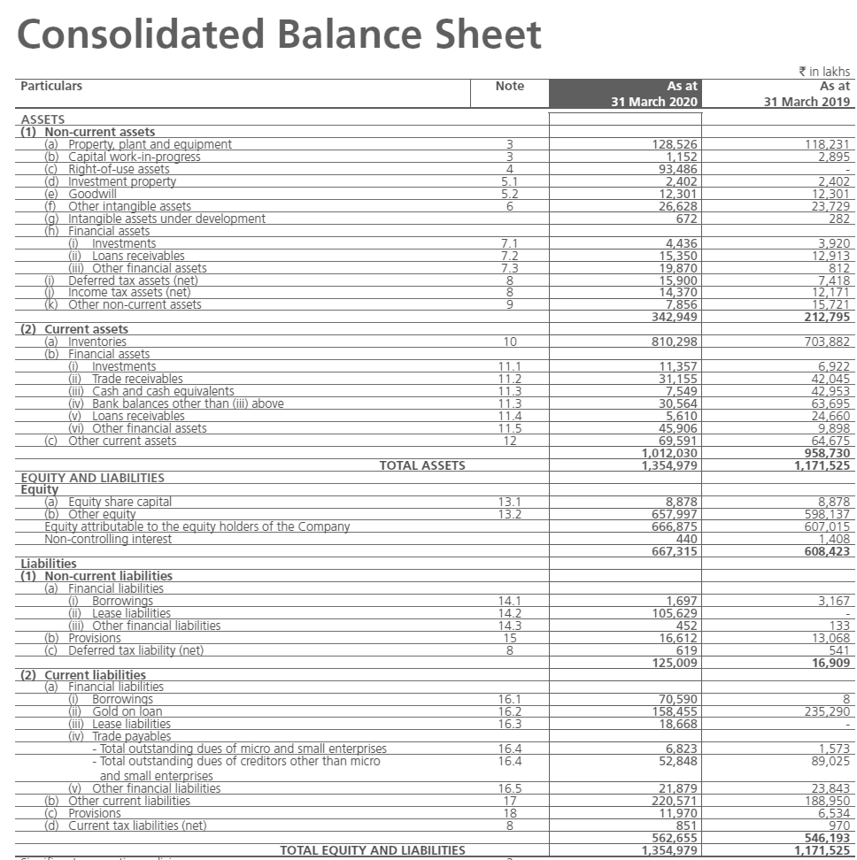

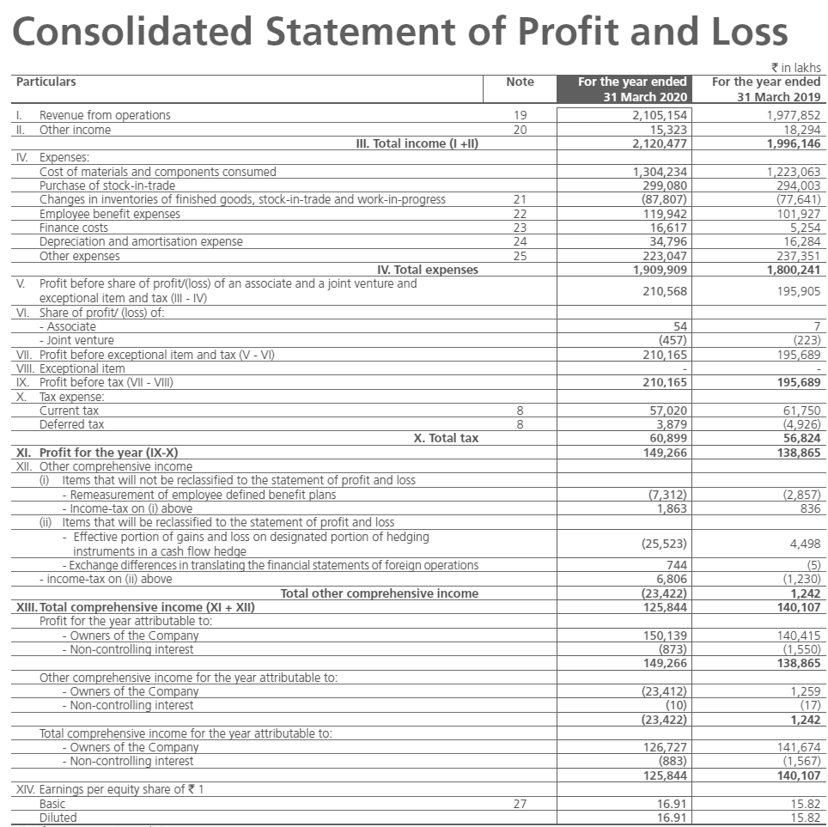

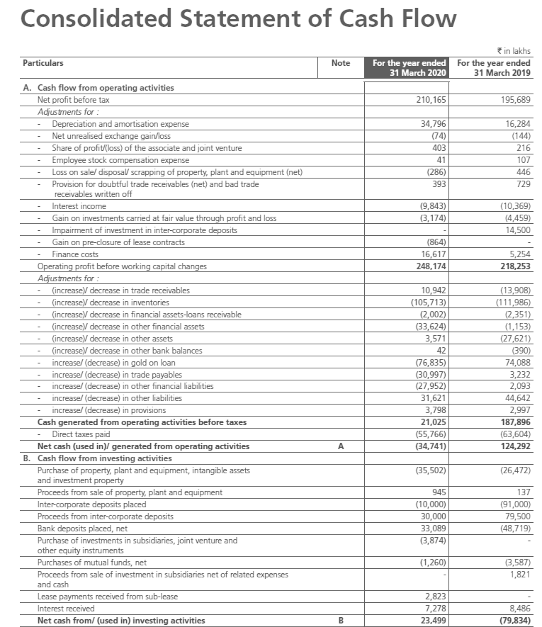

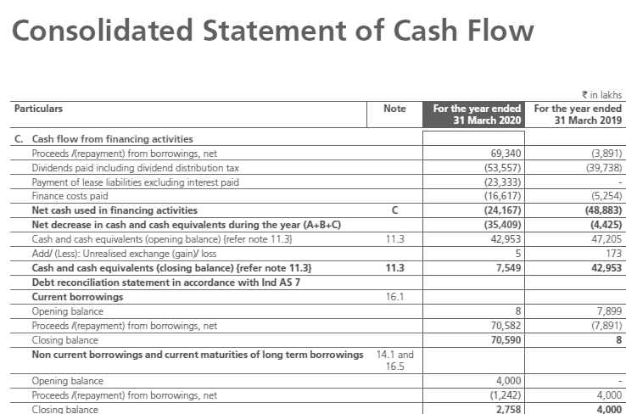

###### **Ratio Calculation and Interpretation**

**Calculation and Interpretation of Ratios**

**Profitability Ratio- *Data in Lakhs**

1. **EBITDA -**

EBITDA = Operating Revenues – Operating Expense

EBITDA Margin = EBITDA / [Total Revenue – Other Income] *100

|  |  |  |  |  |  |
| --- | --- | --- | --- | --- | --- |
| Year | 2020 | 2019 | 2018 | 2017 | 2016 |
| EBITDA | ₹ 2,46,658.0 | ₹ 1,99,149.0 | ₹ 1,64,469.0 | ₹ 1,15,549.0 | ₹ 93,474.0 |
| EBITDA Margin % | 11.72 | 10.07 | 10.18 | 8.82 | 8.26 |

**Analysis - EBITDA margin** is a measure of a company's operating profit as a percentage of its revenue. The acronym stands for earnings before interest, taxes, depreciation, and amortization.

In this case its increasing every year which is sign of good health of the company . In 2020 Titan retained nearly 12% of its revenues

1. **Profit before Tax (PBT) –**

PBT = Total Revenues – Total Operating Expenses

|  |  |  |  |  |  |
| --- | --- | --- | --- | --- | --- |
| Year | 2020 | 2019 | 2018 | 2017 | 2016 |
| PBT | ₹ 2,10,568.00 | ₹ 1,95,905.00 | ₹ 1,54,920.00 | ₹ 1,07,771.00 | ₹ 86,811.00 |

**Analysis - Profit before tax** is a measure that looks at a company's **profits before** the company has to pay corporate **income tax**. It essentially is all of a company's **profits** without the consideration of any **taxes**.

In this case PBT has shown considerable increase from the year 2016 – 2019 but there is less growth from 2019 - 2020 as compared to previous years but still it is higher so nothing much to worry about

1. **Profit after Tax (PAT) –**

PAT = PBT- Applicable taxes

PAT Margin % = PAT/Total Revenues *100

|  |  |  |  |  |  |
| --- | --- | --- | --- | --- | --- |
| Year | 2020 | 2019 | 2018 | 2017 | 2016 |
| PAT | ₹ 1,49,669.00 | ₹ 1,39,081.00 | ₹ 1,12,133.00 | ₹ 80,174.00 | ₹ 67,652.00 |
| PAT Margin % | 7.06 | 6.97 | 6.90 | 6.09 | 5.94 |

**Analysis** - **Profit After Tax** is the total amount that a business earns **after** all **tax** deductions have taken place. ... **Profit after tax** is also seen as a measure of a company's profitability **after** all its expenses have been deducted and can be fully utilised by the company to conduct its business.

Here PAT has increased consistently from last five years which is a good sign.

**PAT margin** is one of the important indicators of the financial health of the company. It is the percentage of revenue remaining after all operating expenses, interest and taxes have been deducted from a company's total revenue.

Here PAT Margin is 7.06 which is good sign.

1. **Return on Equity (RoE)** **–**

RoE = Net Profit / Shareholders Equity* 100

|  |  |  |  |  |  |
| --- | --- | --- | --- | --- | --- |
| Year | 2020 | 2019 | 2018 | 2017 | 2016 |
| RoE | 22.43 | 22.86 | 22.04 | 18.83 | 19.29 |

**Analysis** -  RoE is a measure of management's ability to generate income from the **equity** available to it. ROEs of 15-20% are generally considered **good**. ROE is also a factor in stock valuation, in association with other financial ratios.

Here Company has on average RoE of 22.50 for the last three years which is quite good when compared to the standard RoE.

1. **Return on Assets (RoA) –**

RoA = (Net profit+interest)/Total assets *100

|  |  |  |  |  |  |
| --- | --- | --- | --- | --- | --- |
| Year | 2020 | 2019 | 2018 | 2017 | 2016 |
| RoA | 12.27 | 12.32 | 12.33 | 9.94 | 11.33 |

**Analysis - Return on assets** gives an indication of the capital intensity of the company, which will depend on the industry; companies that require large initial investments will generally have lower **return on assets**. ... ROAs over 5% are generally considered **good**.

Here company has RoA over 10 % which is nearly double of the standard RoA so company is utilising its assets very well and generating huge returns on that which is a good sign .

1. **Asset Turnover Ratio –**

Asset Turnover Ratio = Sales/Total assets

|  |  |  |  |  |  |
| --- | --- | --- | --- | --- | --- |
| Year | 2020 | 2019 | 2018 | 2017 | 2016 |
| Asset Turnover Ratio | 1.56 | 1.70 | 1.71 | 1.56 | 1.79 |

**Analysis -** The **asset turnover ratio** measures the efficiency of a company's **assets** to generate revenue or sales. It compares the dollar amount of sales or revenues to its total **assets**. The **asset turnover ratio** calculates the net sales as a percentage of its total **assets**.

In the retail sector, an **asset turnover ratio** of 2.5 or more could be considered **good**, while a company in the utilities sector is more likely to aim for an **asset turnover ratio** that's between 0.25 and 0.5.

Here asset turnover ratio is 1.56 for the year 2020 which is good for the company .

1. **Inventory Turnover Ratio –**

Inventory Turnover Ratio = Cost of Goods Sold / Inventory

|  |
| --- |
|  |

|  |  |  |  |  |
| --- | --- | --- | --- | --- |
| Year | 2020 | 2019 | 2018 | 2017 |
| Inventory Turnover Ratio | 1.48 | 1.58 | 1.60 | 1.64 |

**Analysis- Inventory turnover** is a **ratio** showing how many times a company has sold and replaced **inventory** during a given period. For most industries, a **good inventory turnover ratio** is between 5 and 10.

Here it is 1.50 on average for the last four years but as Titan also include Jewellery Brand which is a luxurious item so though the ratio is less than average industry but it is on average good.

**Leverage Ratios**

1. **Debt to Equity Ratio –**

Debt to Equity Ratio = Total Debt/Total Equity

|  |  |  |  |  |  |
| --- | --- | --- | --- | --- | --- |
| Year | 2020 | 2019 | 2018 | 2017 | 2016 |
| Debt to Equity Ratio | 1.03 | 0.93 | 0.87 | 0.98 | 0.81 |

**Analysis -** The debt-to-equity ratio is a financial ratio indicating the relative proportion of shareholders' equity and debt used to finance a company's assets. A **good debt** to **equity ratio** is around 1 to 1.5. However, the ideal **debt** to **equity ratio** will vary depending on the industry because some industries use more **debt** financing than others. Capital-intensive industries like the financial and manufacturing industries often have higher ratios that can be greater than 2.

Here in Titan it is only 1.03 which is perfect with respect to the standard equity ratio.

1. **Debt to Asset Ratio** **–**

Debt to Asset Ratio = Total Debt / Total Assets * 100

|  |  |  |  |  |  |
| --- | --- | --- | --- | --- | --- |
| Year | 2020 | 2019 | 2018 | 2017 | 2016 |
| Debt to Asset Ratio | 50.75 | 48.07 | 46.58 | 49.56 | 44.74 |

**Analysis** **-** The **debt to asset ratio**, or total **debt** to total **assets**, measures a company's **assets** that are financed by liabilities, or **debts**, rather than its equity. This **ratio** can be used to measure a company's growth through its acquired **assets** over time.

A lower **debt-to-asset ratio** suggests a stronger financial structure, just as a higher **debt-to-asset ratio** suggests higher risk. Generally, a **ratio** of 0.4 – 40 percent – or lower is considered a **good debt ratio**.

Here it is 50.75 and also increasing at a rate of 2% per year so company should keep a check on it. Till this year it is still good.

**Coverage Ratio**

1. **Interest Coverage Ratio** **–**

Interest Coverage Ratio = EBIT/ Interest expense

|  |  |  |  |  |  |
| --- | --- | --- | --- | --- | --- |
| Year | 2020 | 2019 | 2018 | 2017 | 2016 |
| Interest Coverage Ratio | 12.75 | 34.80 | 28.60 | 27.69 | 19.75 |

**Analysis** **-** The **interest coverage ratio** is used to determine how easily a company can pay its **interest** expenses on outstanding debt.

The company was having a good coverge ratio from the last 4 years but somehow it fall for the year 2020. It is due to the reason as companies Finance Cost tripled for the year 2020 which means company had to pay a lot interest this year due to its loans.

**Solvency Ratios**

1. **Current ratio** **–**

Current ratio = Current assets/current liabilities

|  |  |  |  |  |  |
| --- | --- | --- | --- | --- | --- |
| Year | 2020 | 2019 | 2018 | 2017 | 2016 |
| Current ratio | 1.80 | 1.76 | 1.76 | 1.67 | 1.89 |

**Analysis** **-** The current ratio is a liquidity ratio that measures whether a firm has enough resources to meet its short-term obligations. It compares a firm's current assets to its current liabilities, and is expressed as follows: The current ratio is an indication of a firm's liquidity.

A **good current ratio** is between 1.2 to 2, which means that the business has 2 times more **current** assets than liabilities to covers its debts. A **current ratio** below 1 means that the company doesn't have enough liquid assets to cover its short-term liabilities.

Here in Titan the current ratio is 1.8 which means currently company has nearly 2 times current assets as current liabilities which is very good sign of health.

1. **Acid test ratio –**

Acid test ratio = (Current assets - inventory)/Current liabilities

|  |  |  |  |  |  |
| --- | --- | --- | --- | --- | --- |
| Year | 2020 | 2019 | 2018 | 2017 | 2016 |
| Acid test ratio | 0.61 | 0.64 | 0.58 | 0.62 | 0.60 |

**Analysis** **-**  The acid-test ratio is a type of liquidity ratio, which measures the ability of a company to use its near cash or quick assets to extinguish or retire its current liabilities immediately.

A result of 1 is considered to be the normal **acid-test ratio**. ... A company that has a **acid-test ratio** of less than 1 may not be able to fully pay off its current liabilities in the short term, while a company having a **acid-test ratio** higher than 1 can instantly get rid of its current liabilities.

Here the figure is 0.61 which is not bad and quite well for the company like TITAN. TITAN is a international level company and still has a value of 0.61 which is sign of great health of the company.

**Valuation Ratios**

1. **Price to Sales (P/S) Ratio –**

Price to Sales (P/S) Ratio = Current Share Price / Sales per Share

|  |  |  |  |  |  |
| --- | --- | --- | --- | --- | --- |
| Year | 2020 | 2019 | 2018 | 2017 | 2016 |
| Price to Sales (P/S) Ratio | 4.75 | 5.04 | 6.19 | 7.64 | 8.84 |

**Analysis** **-** The **price-to-sales** (P/S) **ratio** is a **sales** multiple that looks at a company's stock **price** relative to its revenues.

Here it is decreasing every year so it is early alarm for the company to start looking into the matter and investors should also be a little careful and do a thorough research before investing

1. **Price to Earnings Ratio –**

Price to Earning Ratio = Current Market Price / EPS

|  |  |  |  |  |  |
| --- | --- | --- | --- | --- | --- |
| Year | 2020 | 2019 | 2018 | 2017 | 2016 |
| Price to Earning Ratio | 67.23 | 72.34 | 89.73 | 125.50 | 148.73 |

**Analysis** **-** The price-to-earnings ratio indicates the dollar amount an investor can expect to invest in a company in order to receive **one dollar** of that company's earnings. This is why the P/E is sometimes referred to as the price multiple because it shows how much investors are willing to pay per dollar of earnings.

A higher **P/E ratio** shows that investors are willing to pay a higher share **price** today because of growth expectations in the future.

Here P/E ratio is decreasing for the last five years but still it is quite high means still it is a investible grade company but investors should still keep a eye on the company for good future returns.

1. **Price to Book Value Ratio –**

Price to Book Value Ratio = Current Market Price / Book Value

|  |  |  |  |  |  |
| --- | --- | --- | --- | --- | --- |
| Year | 2020 | 2019 | 2018 | 2017 | 2016 |
| Price to Book Value Ratio | 16.86 | 15.67 | 12.63 | 9.03 | 7.62 |

**Analysis** **-** The price-to-book ratio, or P/B ratio, is a financial ratio used to compare a company's current market price to its book value.  The market **value** of a company is its share **price** multiplied by the number of outstanding shares.

Here in TITAN ratio is quite high and increasing from last five years which is quite a good sign. People are willing to invest 16 times its book value which is something investors are always looking around so it is quite good.

**Recommendations-**

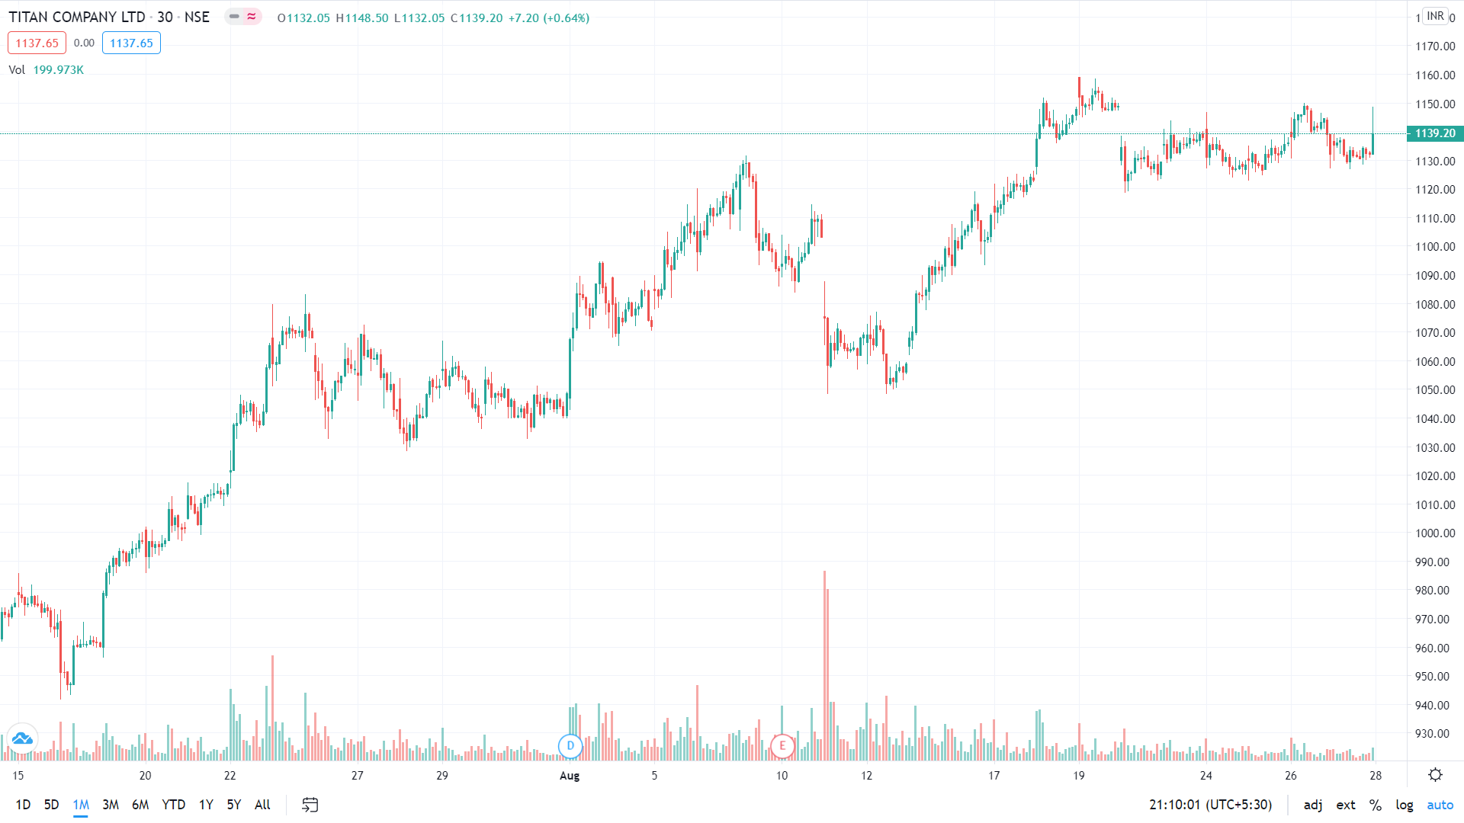

From Last one month Titan share prices have moved from Rs. 946 (lowest) to Rs. 1139.20 (current market price). So we can say share price is in uptrend and is increasing steadily. So it is a good investment opportunities for long term traders. They can go long and remain invested as company is fundamentally strong and India most successful investor has also invested in it.